Name : Zoha Waseem

SapID: 65341

Bs-Cyber Security

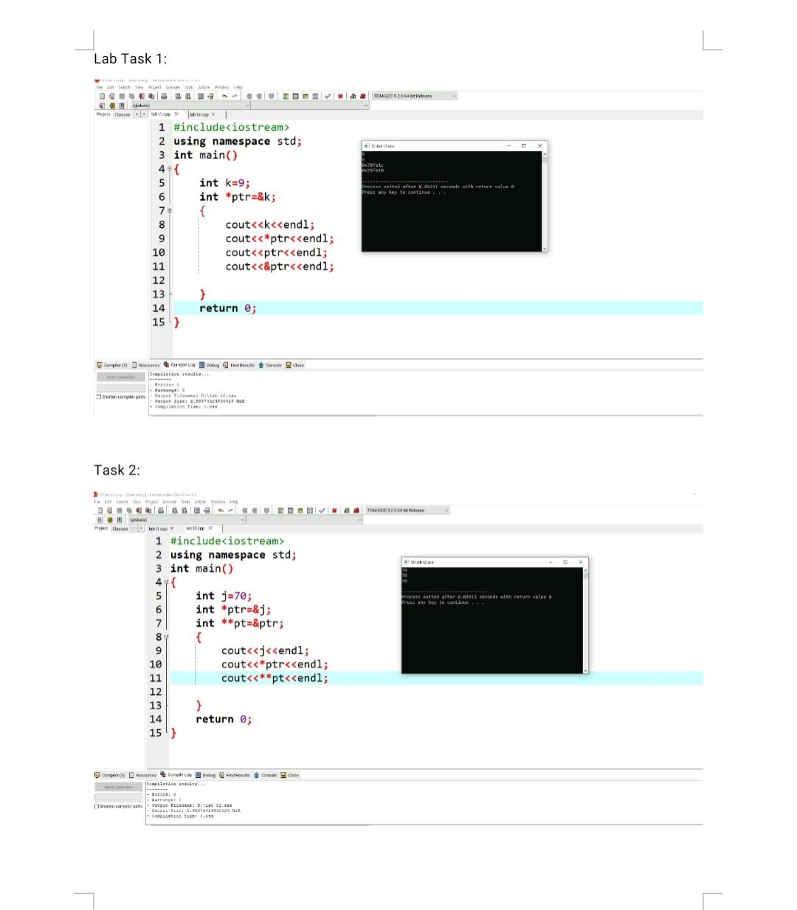

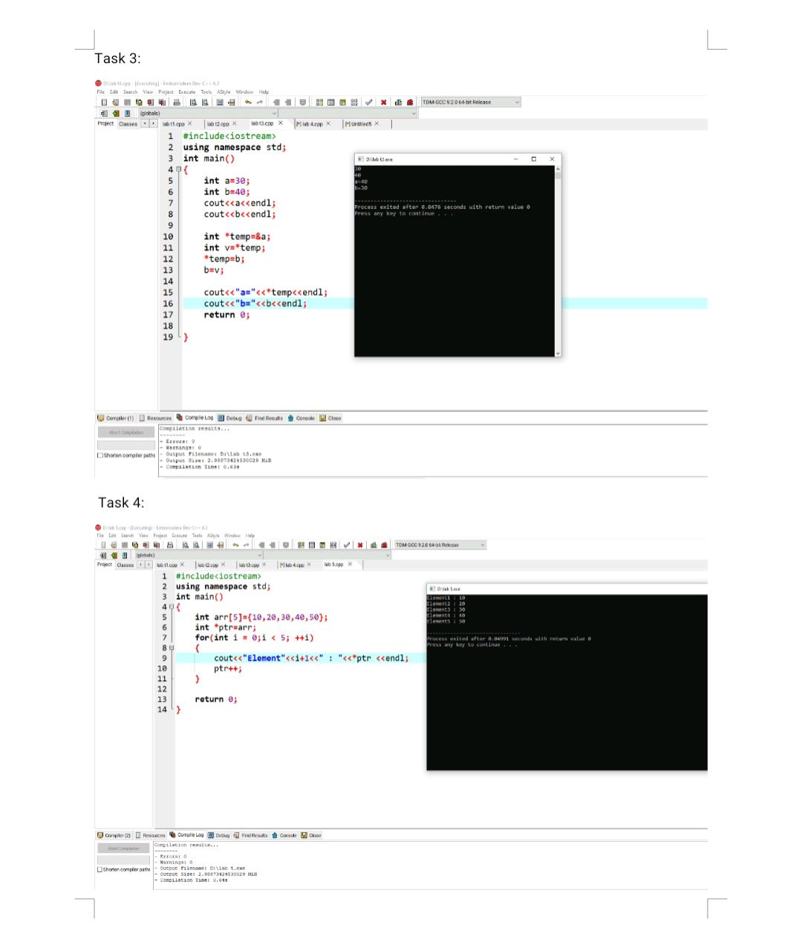

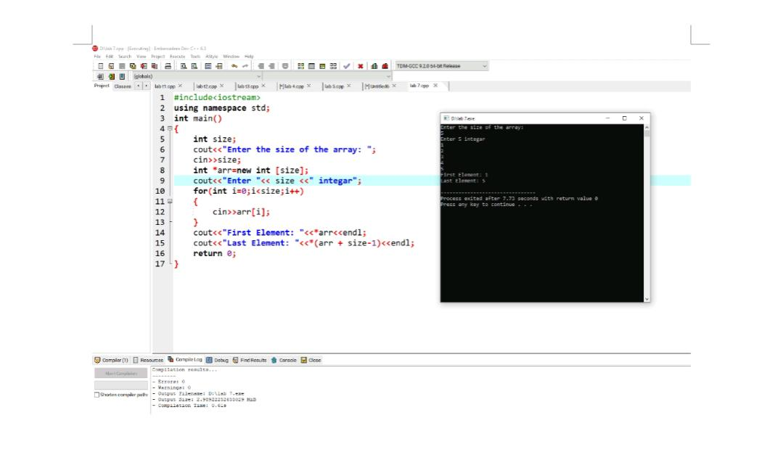

Lab 5:

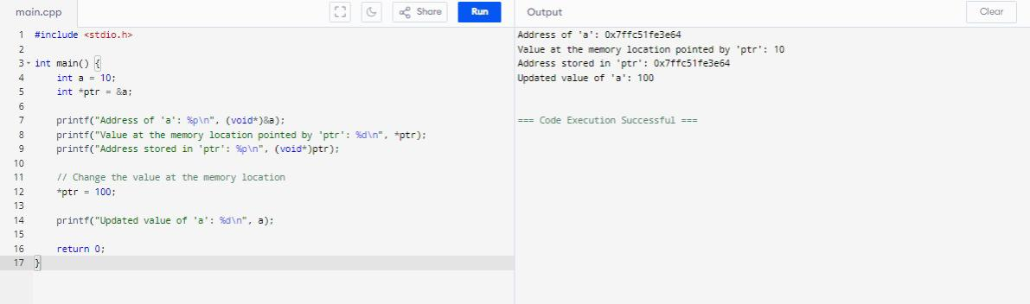

Lab 6:

